No. of Pages | 5
No. of Questions | 7

Department of Computer Science and Engineering
FINAL EXAMINATION FALL 2012

CSE490/EEE453: LAN Switching and WAN Technologies
Total Marks:75 Time Allowed: 3 Hours

- Answer any FIVE (5) questions out of the given SEVEN(7) questions.
- Figure in bracket [] next to each question indicates marks for that question.

Question No. 1

- A network administrator asked an assistant to remove several VLANs from a switch. When the assistant entered in the no vlan 1 command an error was received. What was the cause of the error? [3 marks]
Figure No. 1
SW1(config)#interface fa0/11
SW1(config-if)# switchport mode access
SW1(config-if)# switchport access vlan 10

- Explain the above commands shown in figure no.1. What will happen if a “no” is put in front of the last command, what effect will it have on the port fa0/11? [3 marks]
- What is the word “tagging” mean in VLANs? Who or what does the tagging? [3 marks]
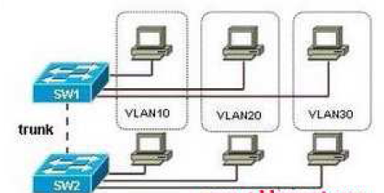
Figure No. 2

- Refer to the figure no.2 above, Switch SW2 has been newly purchased and added to the network. What configuration should be applied to SW2 so that it receives VLAN information from SW1, and synchronizes VLAN information? [4 marks]
- What is the purpose of DTP? [2 marks]

Question No. 2

- What happens if all the switches in a network are in server mode? Will hamper the performance of the network? [3 marks]

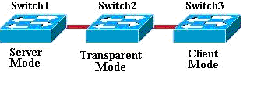
Figure No. 3
- In the above figure no. 3, what is the difference between Transparent and Server mode switch? [3 marks]
- Inter VLAN routing is not possible without routers, true or false? Justify your answer. [3 marks]
R(config)#interface f0/0.4
R(config-subif)#encapsulation dot1q 4
R(config-subif)#ip add 192.168.10.130 255.255.255.128
R(config-subif)#interface f0/0.5
R(config-subif)#encapsulation dot1q 5
R(config-subif)#ip add 192.168.10.10 255.255.255.128
R(config-subif)# interface f0/0
R(config-if)#no shutdown

Figure No. 4

- Why did the network administrator create two subinterfaces in the above output shown in figure no. 4? The router receives a frame on physical interface f0/0. The destination IP address is 192.168.10.222/25. What will the router do? [4 marks]
- What are advantages of using traditional intervlan routing? [2 marks]

Question No. 3

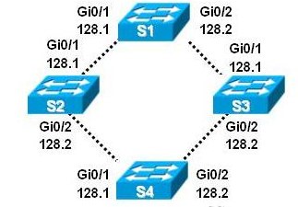
Figure No. 5

- Refer to the exhibit above in figure no. 5; S1 is the root switch. Now S4 has equal cost paths to the root switch, how will it decide its root port, explain. [4 marks]
- How is the root bridge chosen if all the switches have the different priorities? What is the default priority of a switch? [3 marks]
- By default, what is used to calculate the spanning-tree path cost? [2 marks]
- Is STP is disabled, what are the problems that can occur? Just name them. [3 marks]
- Which states in STP are no longer available in RSTP, and why? [3 marks]

Question No. 4

- What is the 3P s rule regarding ACLs? [3 marks]
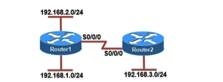
Figure No. 6
- Refer to the figure no. 6 above, configure a named ACL called ACCESS so that all hosts from the 192.168.3.0/24 cannot ping both networks at Router 1, but other types of traffic from 192.168.3.0/24 network is allowed. DON’T forget to place the ACL. All other traffic is also allowed. [4 marks]
- Referring to the same figure no.6 above, the network administrator wishes to block all telnet access into the router Router 1 except PC with the IP address 192.168.1.1/24 will be allowed to telnet into the router Router 1. Write the ACL and place it properly. [4 marks]
- What is the advantage of named ACL over number ACLs? [2 marks]
- How is Dynamic ACL different from Reflexive ACLs? [2 marks]

Question No. 5

<output omitted>
ip dhcp excluded-address 200.20.21.10 200.20.21.15

ip dhcp pool SALESNetwork
network 200.20.20.0 255.255.255.0
default-router 200.20.21.10
dns-server 200.20.21.15
!
interface FastEthernet 0/0
ip address 200.20.21.10 255.255.255.0
duplex auto
speed auto
!
<output omitted>x

Figure No. 7

- Refer to router configuration output shown in figure no. 7. Hosts connected to this router are having problems with DHCP. Find the problem/s? [3 marks]
- What is the difference between DHCP manual allocation and dynamic allocation? [3 marks]
- What commands are used to statically map the following private address to the public address using NAT? (192.168.10.10 / 24 to 141.63.7.20 / 26 ). When does this type of static mapping required? [4 marks]
- A company has two subnetworks for its two branches, 192.168.22.0/24 and 192.168.33.0/24. Write the commands, which are necessary for a router to dynamically translate any address of the company to a public address pool of 130.16.32.130/28 with PAT. [5 marks]

Question No. 6

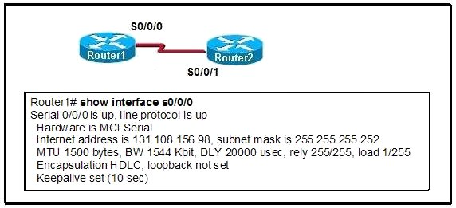
Figure No. 8

- Refer to the output shown in figure no. 8, the network administrator cannot ping from Router 2 to Router 1. What can be the problem? [3 marks]
- After LCP creates the connection, what kinds of parameters are negotiated between the two routers, explain briefly? [4 marks]
- For CHAP authentication the passwords between the routers do not have to be the same, true or false justify your answers. [4 marks]
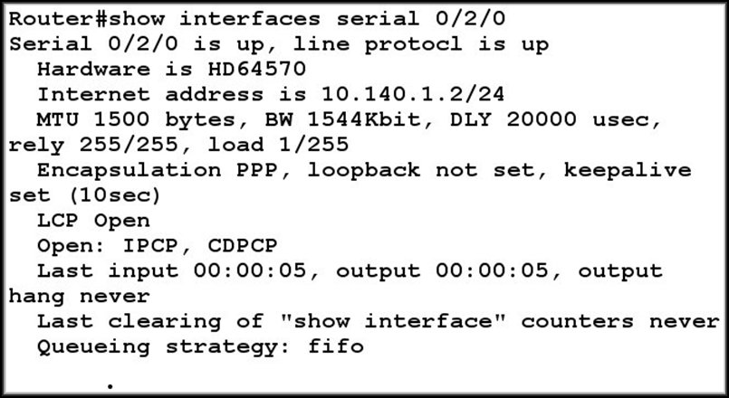
Figure No. 9

- Referring to the output shown above in figure no. 9, explain the part circled. What do the two lines imply? [4 marks]

Question No. 7

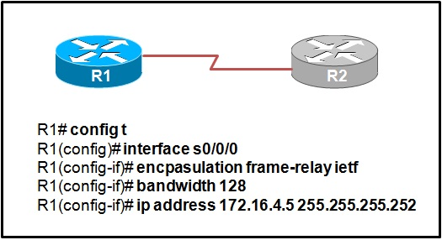
Figure No. 10

- R1 is not able to ping R2 shown in figure no. 10. What are the probable reasons? [3 marks]

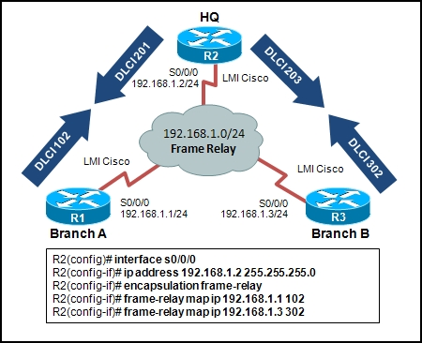
Figure No. 11

- For figure no.11, the links between R2 and the other routers are not operational. What are the probable reasons based on the commands shown? [3 marks]
- For figure no.11, shows static mapping, if no static mapping is done, how will the routers connect the DLCI numbers to the layer 3 IP addresses, explain briefly? [3 marks]
- For figure no. 11, R3 receiving no routing updates from R1, why? How can this problem be solved? [4 marks]
- A company has a CIR of 16kbps and the access rate of the link is 64 kbps. What is the BE capacity of the company? [2 marks]

THE END

